CUSTOM CHAMPIONSHIP RINGS
*Team Logo, Name, Number & Division
*Minimum of 6 Rings
*Ring style shown for example only, each team will have a custom ring with their logo
CUSTOM (NO STONES) |  | CUSTOM BLING (STONES)
WHITE LUSTRE | STERLING SILVER | WHITE LUSTRE | STERLING SILVER
$175 | $225 | $230 | $280
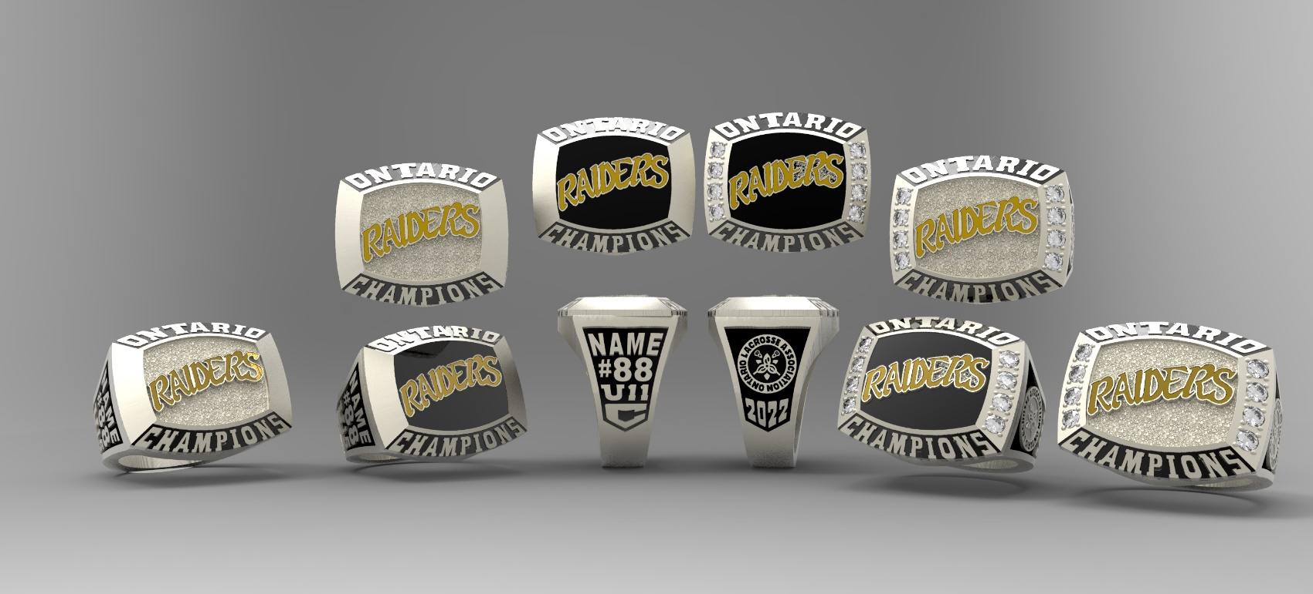

Please submit completed order form to foschiaandco@gmail.com. The TEAM CONTACT will be contacted to verify the order and given a total cost for each ring individually including HST. Individual E-transfer payments accepted at foschiaandco@gmail.com. Credit Card payments are accepted but a 3.5% surcharge will be added.
Please direct any questions to Ann-Margaret Foschia at foschiaandco@gmail.com or 905-264-6557.

TEAM NAME |  | DIVISION
CONTACT NAME |  | CONTACT EMAIL
CONTACT
CELL PHONE
*Please note that all team rings will be shipped to one shipping address (confirmed once order placed). Distribution is the responsibility of the Team Contact.*

NAME ON RING  *limit 9 characters* | JERSEY  NUMBER | FINGER  SIZE | OLA CUSTOM |  | OLA CUSTOM BLING  (Team Logo, 8 Stones, Name, Number & Division)
 |  |  | WL  $175.00 | SS  $225.00 | WL  $230.00 | SS  $280.00

