FOSCHIA & CO Championship Rings
2022 slo-pitch ontario
SQUARE OR ROUND  (NO STONES) |  | SQUARE WITH STONES  *STONES ARE ONLY AVAILABLE ON THE SQUARE STYLE RING |  | SPO - BAND |  | SPO - LADIES’
STERLING SILVER | WHITE LUSTRE | STERLING SILVER | WHITE LUSTRE | STERLING SILVER | WHITE LUSTRE | STERLING SILVER | WHITE LUSTER
$205 | $160 | $225 | $180 | $145 | $110 | $135 | $100
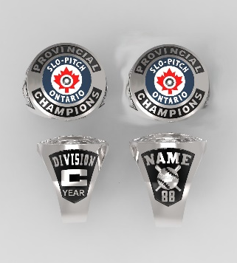 |  |  |  | 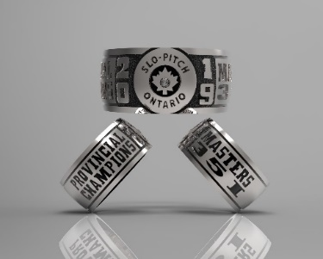 |  | 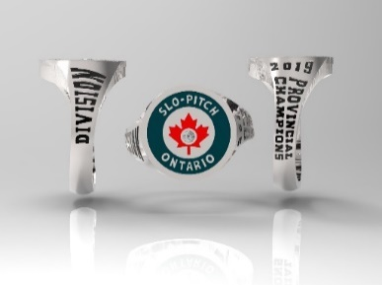

Please submit completed order form to foschiaandco@gmail.com. The TEAM CONTACT will be contacted to verify the order and given a total cost for each ring individually including HST. Individual E-transfer payments accepted at foschiaandco@gmail.com. Credit Card payments are accepted but a 3.5% surcharge will be added.
ADDITIONAL ORDER FORMS CAN BE DOWNLOADED AT www.foschia.ca/spo.
Please direct any questions to Ann-Margaret Foschia at foschiaandco@gmail.com.

TEAM NAME |  |  |  |  |  |  |  | DIVISION
TEAM CONTACT |  |  |  |  |  |  |  | CONTACT CELL NUMBER
CONTACT EMAIL
*ALL RINGS SHIPPED TO ONE ADDRESS ONLY*
STREET ADDRESS FOR SHIPPING:
CITY /PROVINCE/POSTAL CODE:
Please fill in: |  |  |  |  | Please check one: RING STYLE |  |  |  |  |  |  |  | Please check one:  METAL
 |  |  |  |  | *SQUARE & ROUND RINGS ONLY*
LAST NAME |  | JERSEY NO. |  | FINGER SIZE | SQUARE  (NO STONES) | SQUARE  (STONES) | ROUND  (NO STONES) |  | NAME ON RING  MAX. 9 CHARACTERS  *SQUARE & ROUND STYLES ONLY* |  | BAND | LADIES’ | STERLING SILVER | WHITE LUSTRE
 |  |  |  |  | CHECK ONE ONLY

