2023 SPN Championship Rings
ORIGINAL |  |  |  | SQUARE |  |  |  | ROUND
STERLING SILVER |  | WHITE LUSTRE |  | STERLING SILVER |  | WHITE LUSTRE |  | STERLING SILVER |  | WHITE LUSTRE
LARGE | SMALL | LARGE | SMALL | LARGE | SMALL | LARGE | SMALL | LARGE | SMALL | LARGE | SMALL
$230 | $210 | $180 | $165 | $225 | $205 | $175 | $160 | $225 | $205 | $175 | $160
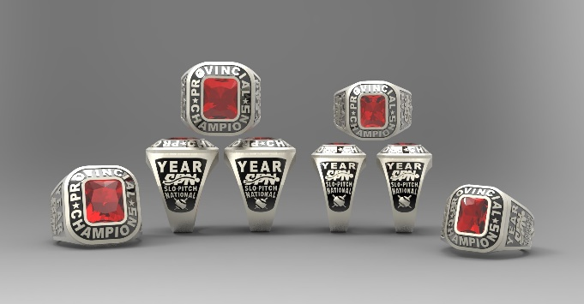

Please submit completed order form to foschiaandco@gmail.com. The TEAM CONTACT will be contacted to verify the order and given a total cost for each ring individually including HST. Individual E-transfer payments accepted at foschiaandco@gmail.com. Credit Card payments are accepted but a 3.5% surcharge will be added.

Please direct any questions to Ann-Margaret Foschia at foschiaandco@gmail.com.

TEAM NAME |  |  |  |  |  |  | DIVISION
TEAM CONTACT |  |  |  |  |  |  | CONTACT CELL NUMBER
CONTACT EMAIL
*ALL RINGS SHIPPED TO ONE ADDRESS ONLY*
STREET ADDRESS FOR SHIPPING:
CITY /PROVINCE/POSTAL CODE:
LAST NAME |  | FINGER SIZE | ORIGINAL  CIRCLE STONE COLOUR & CHECK ONE SIZE |  |  |  | ROUND  (CHECK ONE) |  | SQUARE  (CHECK ONE) |  |  | METAL CHOICE  (CHECK ONE)
 |  |  | BLUE | RED |  | GREEN
 |  |  | LARGE |  | SMALL |  | LARGE | SMALL | LARGE |  | SMALL | STERLING SILVER | WHITE  LUSTRE

